ME40064: System Modelling and Simulation

Assignment 1: Static MATLAB-Based FEM Modelling

# Summary

During this assignment, an FEM-based simulation tool was developed to solve the static diffusion-reaction equation in a 1D mesh.

Contents

Summary 1

Part 1: Software Verification and Analytical Testing 2

a. Function to calculate a local element matrix for the Diffusion term 2

b. Function to calculate a local element matrix for the Reaction term 2

c. FEM Solver 3

Pseudo-Code 3

Function to calculate a local element vector for the Source term 3

Analytical Test One – Laplace’s Equation 4

Analytical Test Two – Diffusion-Reaction Equation 6

Part 2: Modelling and Simulation Results 6

a. Constant Source Term 7

i. Parameter Space Study 7

ii. Predictions of Particle Diffusion due to Thermophoresis 8

iii. Mesh Resolution Study 8

b. Linear Source Term 13

i. Deriving the analytical expression for the modified Source Vector 13

ii. Implementation and Investigation 13

Conclusion 13

Appendix: Source Code 17

LaplaceElemMatrix function 17

ReactionElemMatrix function 17

ReactionUnitTest script 17

ElemVector function 18

FEMsolver function 19

analytical_tests script 20

ThermophoresisCaseStudy script 21

# Part 1: Software Verification and Analytical Testing

## Function to calculate a local element matrix for the Diffusion term

A function, LaplaceElemMatrix, was written to calculate a local element matrix for the Diffusion term. The source code can be found in the Appendix. The runtests() command was used to run CourseworkOneUnitTest and the results were as shown in Figure 1.

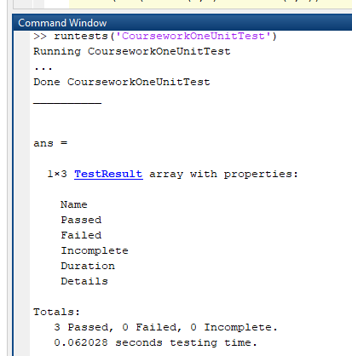

Figure 1: Screenshot showing that the function passed the unit test.

## Function to calculate a local element matrix for the Reaction term

A function, ReactionElemMatrix, was written to calculate a local element matrix for the Reaction term. ReactionUnitTest was written to test that: the matrix was symmetrical, the same matrix was generated for the same size elements, and that one specific matrix was generated correctly, using the example from the tutorials. The source code for both the function and the unit test can be found in the Appendix. The results of the unit test are as shown in Figure 2.

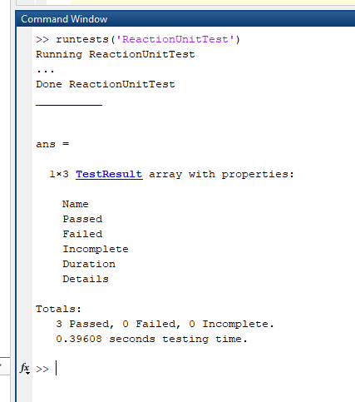

Figure 2: Screenshot showing that the function passed the unit test.

## FEM Solver

An FEM solver was written based on the above functions to solve the static diffusion-reaction equation in a 1D mesh. The source code can be found in the Appendix.

### Pseudo-Code

The pseudo-code for the FEM solver was as follows:

1. Initialise mesh

2. Define material coefficients

3. Create & initialise the global matrix and vector to zero

4. Loop over elements: calculate local element matrices and

add to correct location in global matrix

5. Loop over elements: calculate local element vectors and

add to correct location in global vector

6. Apply boundary conditions to global matrix and/or vector

7. Solve the final matrix system

8. Plot the solution vector

### Function to calculate a local element vector for the Source term

The element vector was initially calculated inline with the FEM solver function because it was relatively simple, but when it was later modified to allow for a linear source term, it became more complicated, and so a function was written to calculate it: ElemVector. The source code can be found in the Appendix.

### Analytical Test One – Laplace’s Equation

A script was written to solve Laplace’s Equation for the 1D 4 element mesh shown in Figure 3, using the FEMsolver function, with various boundary conditions. The source code can be found in the Appendix.

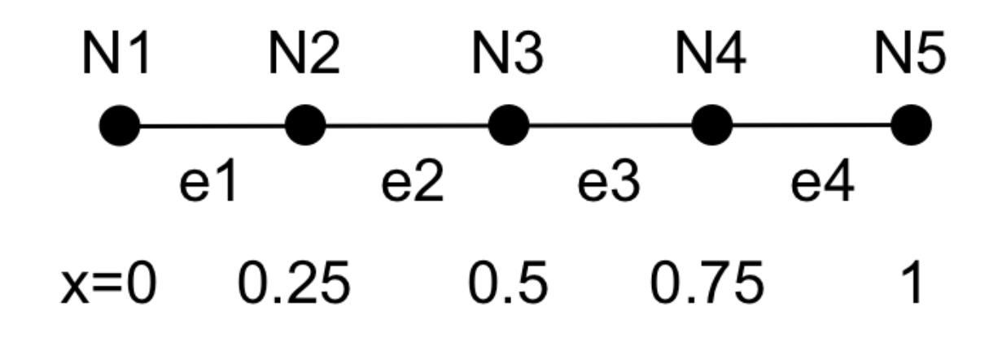

Figure 3: 1D 4 element mesh

#### Two Dirichlet Boundary Conditions

First, the equation was solved with two Dirichlet boundary conditions. Figure 4 shows the analytical solution compared to the numerical solution. The numerical solution is 100% accurate. This is because the analytical solution is linear, so there are no residual errors due to using linear basis functions.

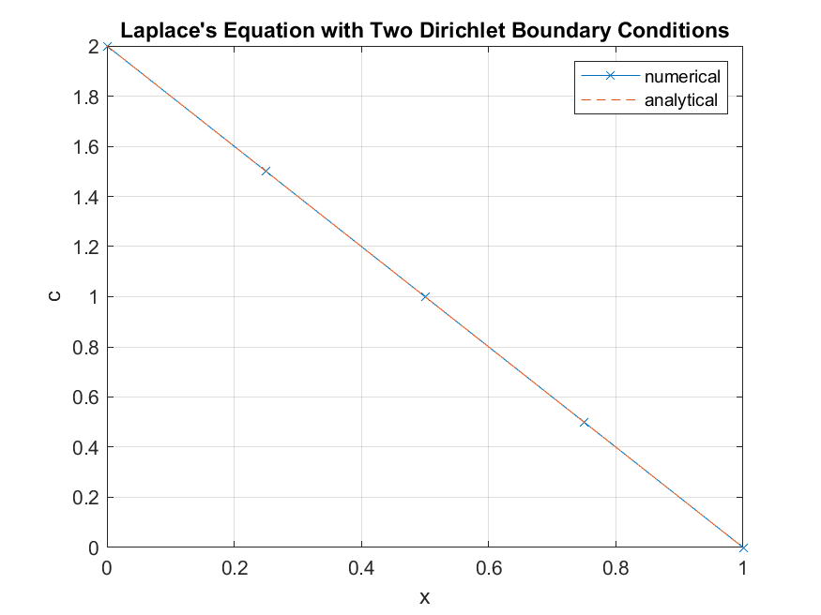

Figure 4: Analytical Test 1i

#### One Neumann and One Dirichlet Boundary Conditions

Next, the equation was solved with one Dirichlet and one Neumann boundary condition. This had the effect of making the gradient of the whole solution equal to the gradient of the Neumann boundary condition at x=1. This is because the solution is linear so it can only have one gradient. Figure 5 shows the plot of the numerical solution.

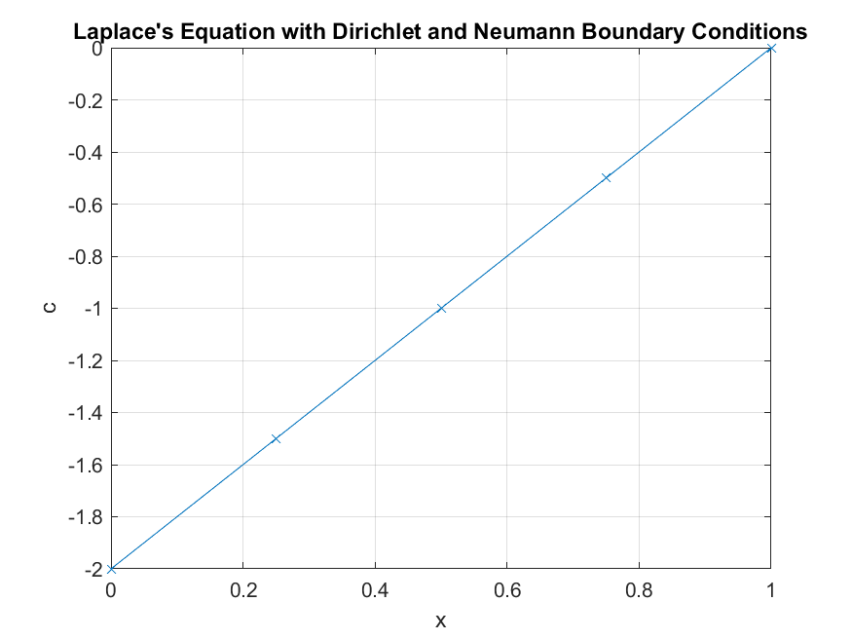

Figure 5: Test 1ii

### Analytical Test Two – Diffusion-Reaction Equation

Next, the solver was used to solve the Diffusion-Reaction Equation to check that the reaction term was coded correctly. The source code can be found in the same analytical_tests script in the Appendix as tests 1i and 1ii.

#### Two Dirichlet Boundary Conditions

The equation was solved with two Dirichlet boundary conditions. Figure 6 shows that the numerical solution converges on the analytical solution as mesh resolution increases, and that it is indistinguishable by eye from the analytical solution at Ne=50.

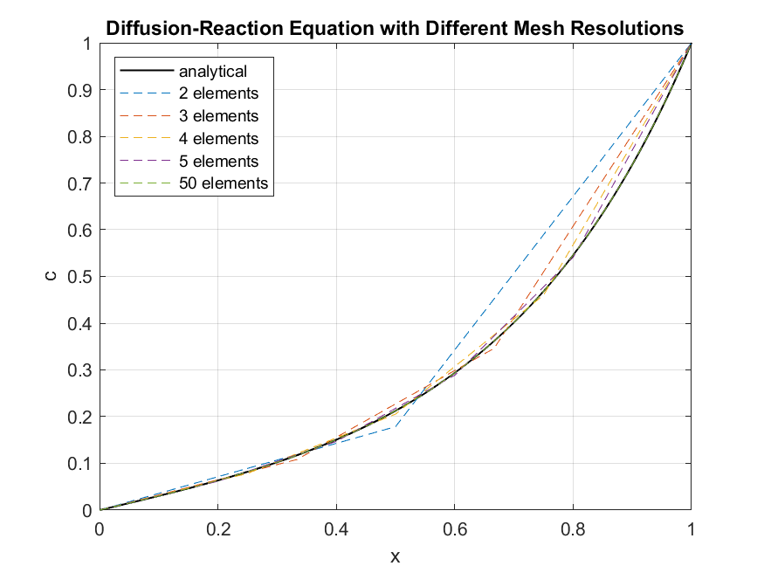

Figure 6: Test 1iii

# Part 2: Modelling and Simulation Results

Thermophoresis is a phenomenon in which particles of different types diffuse differently through a medium depending on the local temperature gradient that they are exposed to. The particles diffuse at a rate that is negatively proportional to the local temperature gradient i.e. the steeper the negative temperature gradient, the faster the particles will diffuse. In biomaterial processing this effect can be harnessed to create a spatially varying concentration of these particles, which causes a spatially varying stiffness to be created in the biomaterial. This is useful for growing cell cultures under biologically realistic conditions.

In Part 2 the code was used to model steady-state heat transfer through a material that is filled with small diameter heating channels. By varying the temperature of the heating liquid, the flow rate, or the spatial distribution of temperature in these channels, different temperature profiles can be obtained for the thermophoresis-based manufacturing process. The behaviour of this system was investigated and characterised for its different parameters.

Figure 7 shows the setup and the parameters to be investigated. The source code for the entire case study can be found in the Appendix under ‘ThermophoresisCaseStudy’.

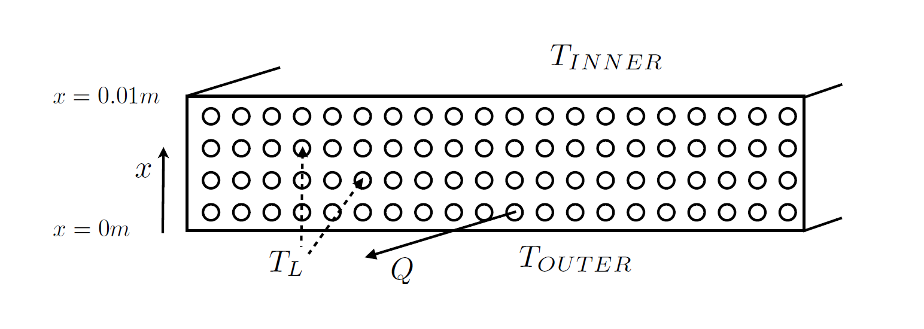

Figure 7: Thermophoresis Parameters

## Constant Source Term

The initial model of the system was as follows:

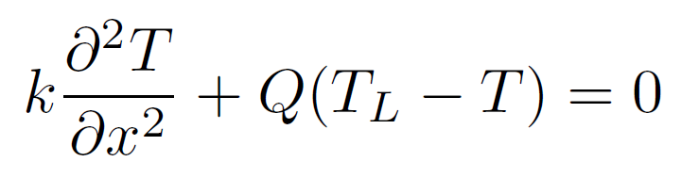

By comparing it to the equation that had been derived previously, k can be equated with the diffusion coefficient D, Q can be equated with the reaction coefficient lambda, and QTl can be equated with the source term f.

### Parameter Space Study

The code was used to model the system with various combinations of Q and T­l. All other parameters were held constant. The results are shown in Figures 8, 9, and 10.

The temperature gradient is always negative, because Tin<Tout and TL is always between the two, but it can be made more and/or less negative by varying Q and TL.

##### Effect of Varying TL

It can be deduced from the equation above that the curvature of the temperature with respect to T is proportional to the difference between the temperature of the material and the temperature of the liquid, T-TL. Thus, when TL<T the curvature is positive (see Figure 10ai), and when TL>T the curvature is negative (see Figure 10aiii). When T-TL decreases, the curvature also decreases. This can be due either to increasing TL (see Figure 10b) or to T decreasing through the material. Due to this, if TL is set to the mean of Tin and Tout, the curvature changes from positive to negative at the midpoint as the temperature of the material passes this point. This can be seen in Figures 8aii, 9aii, and 10aii.

For a given change in parameters, the temperature gradient becomes both more positive and more negative at different points in the material. An increase in curvature will make ‘initial’ gradients more negative and ‘final’ gradients more positive, and vice versa. Alternatively, as the curvature mores away from zero it will make ‘steep’ gradients steeper and ‘shallow’ gradients shallower. This can be seen by comparing Figure 8b and Figure 9b.

In general, a more negative temperature curvature will result in a greater average temperature, because there is greater area under the convex curve than the concave one.

##### Effect of Varying Q

The curvature is also proportional to the flow rate, Q. The faster the fluid is flowing, the more heat that can be transferred and carried away. This means that Q acts as a scaling factor for the curvature (see Figure 10). When Q increases, ‘steep’ gradients become steeper and ‘shallow gradients become shallower (see Figure 9). This results in a lower average temperature for a greater flow rate (see Figure 8).

### Predictions of Particle Diffusion due to Thermophoresis

If some particles were initially placed at x=0 and allowed to diffuse for a short amount of time, their distribution, and hence the variation in stiffness, might change with Q and TL, based on the effect these have on the temperature gradients in the material.

It should be noted that the time period of interest is quite short, so the particles would not have time to diffuse past the local gradient. Thus, the gradient of interest is primarily that at x=0. The steeper the negative temperature gradient, the faster the particles would diffuse. In this way, the system may be thought of as analogous to marbles rolling down the x-T curve (refer to Figure 8). They are not exactly analogous, as gravity affects acceleration and not velocity, but in both situations the gradient affects the flow of particles or marbles, and the concentration would be higher at lower speeds – bunching up like cars in a traffic jam on a motorway.

With this in mind, a steeper negative gradient would have the effect of faster diffusion and lower concentration, and therefore lower stiffness, while a shallower gradient would result in slower diffusion and higher concentration, and therefore higher stiffness. The temperature gradient and therefore the stiffness distribution of the material can be controlled by varying Q and TL.

For example, if one wanted the fastest possible diffusion at x=0, one should select TL=Tin and Q=1.5. If one wanted to impede diffusion at x=0 as much as possible, one should select TL=Tout and Q=1.5. If one wanted to ensure that the rate of diffusion was as even as possible throughout the material, one should select TL=(Tin+Tout)/2 and Q=0.5. Refer to Figure 8 for evidence and visual aids.

### Mesh Resolution Study

The results from the mesh resolution study are shown in Figure 11. At low mesh resolutions, the accuracy will be low because there is a large residual error because the linear basis functions cannot fit the curved solution. As the number of elements increases, the residual error decreases and the accuracy increases. The solution converges nicely, and the solution with 20 elements looks very similar to the solution with 100 elements. This lends credence to the results, and it can be expected to have a high degree of accuracy provided that the model was accurate to the situation in the first place.

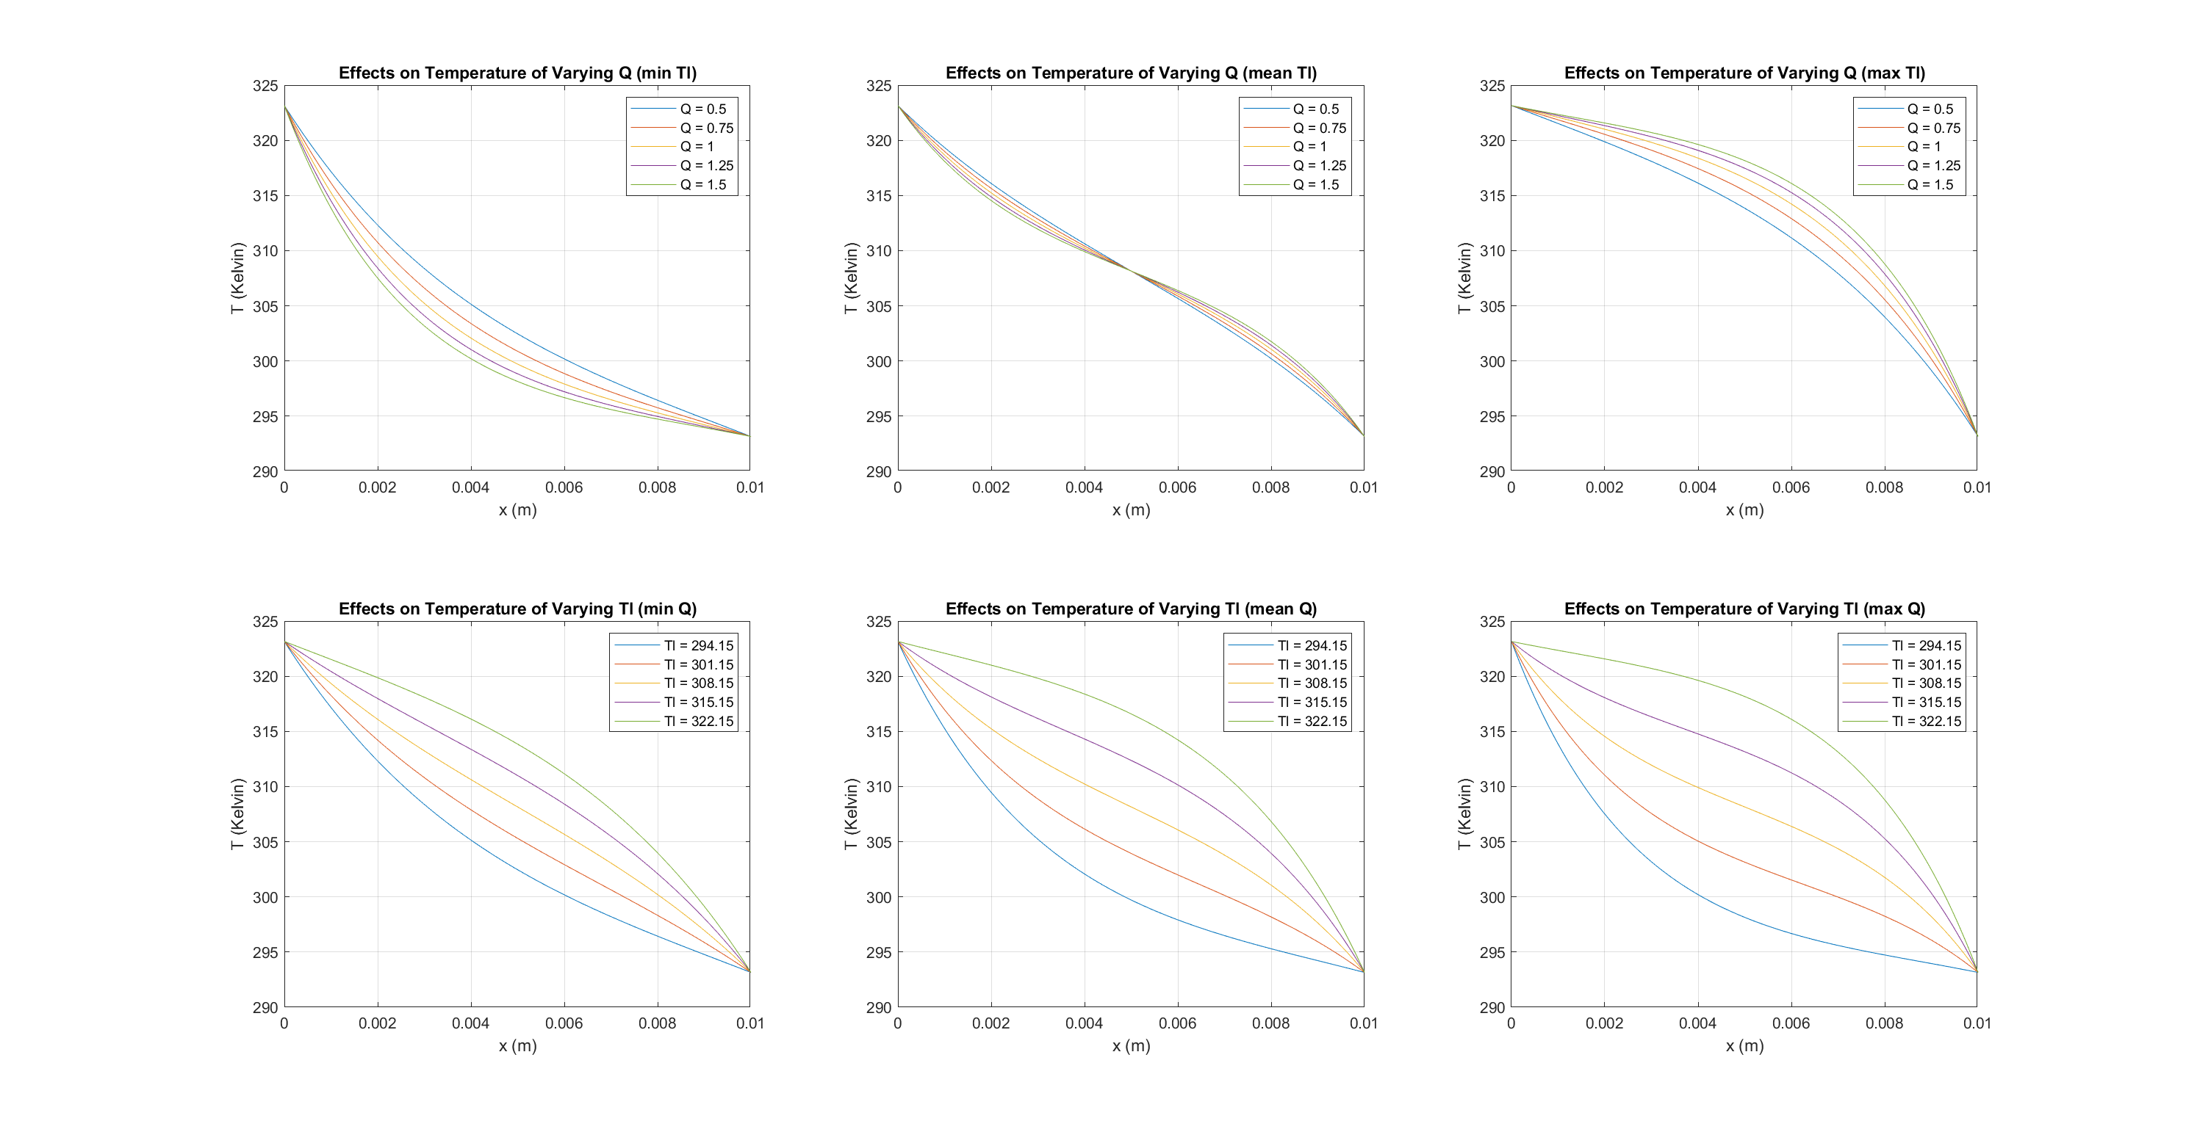

Figure 8ai (top left) to 8biii (bottom right): Effects on Temperature of Varying Q and TL

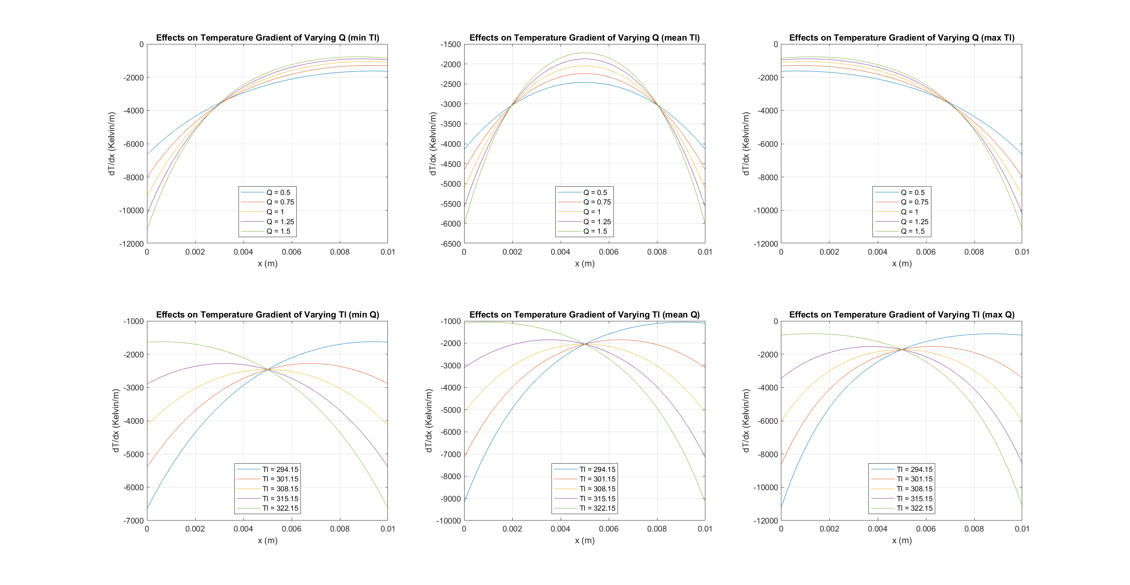

Figure 9ai (top left) to 9biii (bottom right): Effects on Temperature Gradient of Varying Q and T­L

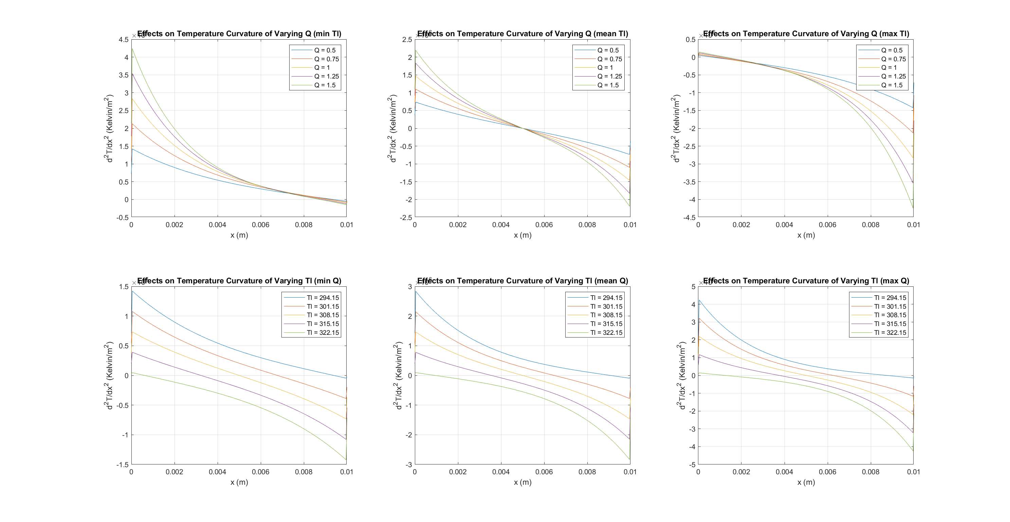

Figure 10 ai (top left) to 10biii (bottom right): Effects on Temperature Curvature of Varying Q and T­L

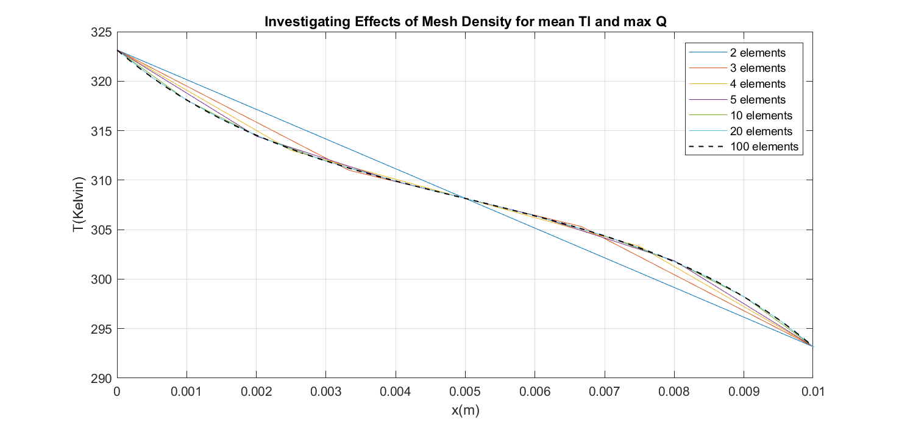

Figure 11: Mesh Convergence Study

## Linear Source Term

It was suggested that varying the temperature of the liquid from one channel to the next could provide greater control of the temperature distribution. This variation in temperature and its effect on heating performance can be represented by a linear function of x for the source term. The equation to be solved is now:

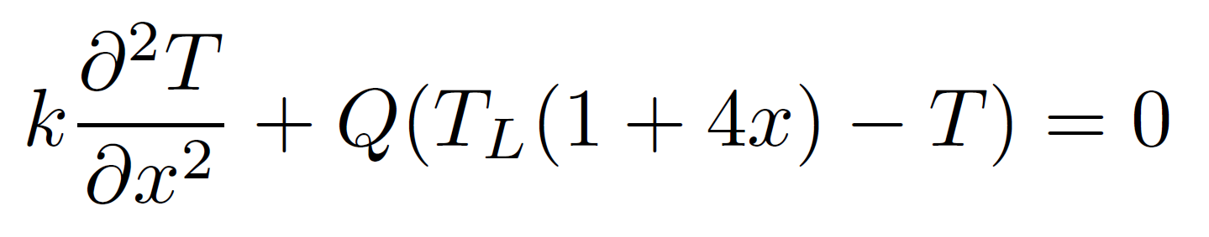

### Deriving the analytical expression for the modified Source Vector

The modified local element Source term vector was found to be as follows:



The derivation for this can be seen in Figure 12.

### Implementation and Investigation

The modified source term was implemented in the FEMsolver function and the ThermophoresisCaseStudy script, as can be seen in the source code in the Appendix. The code was written such that, if the ‘f’ input argument is scalar the constant source term method will be used, and if it is a vector of length 2 the linear method will be used. If it is of any other length, an ‘invalid source term’ error will be thrown. This is useful because it means that code calling the FEMsolver function that was written before this implementation does not need to be rewritten to hand it another input argument, but the parameters can still be easily adjusted.

With regard to the effect that the modified source term has on the solution, it is known that the curvature of the temperature is proportional to the difference between the temperature of the material and the temperature of the liquid, T-TL. The modified source term has the effect of increasing the effective TL as x increases. Thus, the curvature of the temperature of the linear solution is initially (at x=0) the same as that of the constant source term solution, but it decreases through the material more than the constant solution, and so diverges from it and is of a more negative curvature at x=1. This results in initial gradients becoming more positive and final gradients becoming more negative, with increasing magnitude as x increases. This also results in a higher average temperature because there is a greater area under the curve. Refer to Figure 13 for evidence and visual aids.

These effects would be exacerbated if the linear coefficient of the source term was made more positive, and they would be inverted if the linear coefficient of the source term was multiplied by -1. This is illustrated in Figure 14.

# Conclusion

A Finite Element Method solver was written in MATLAB code and verified with various unit and analytical tests. It was then used to model a Thermophoresis system and the results were analysed to gain understanding of the characteristics of the system.

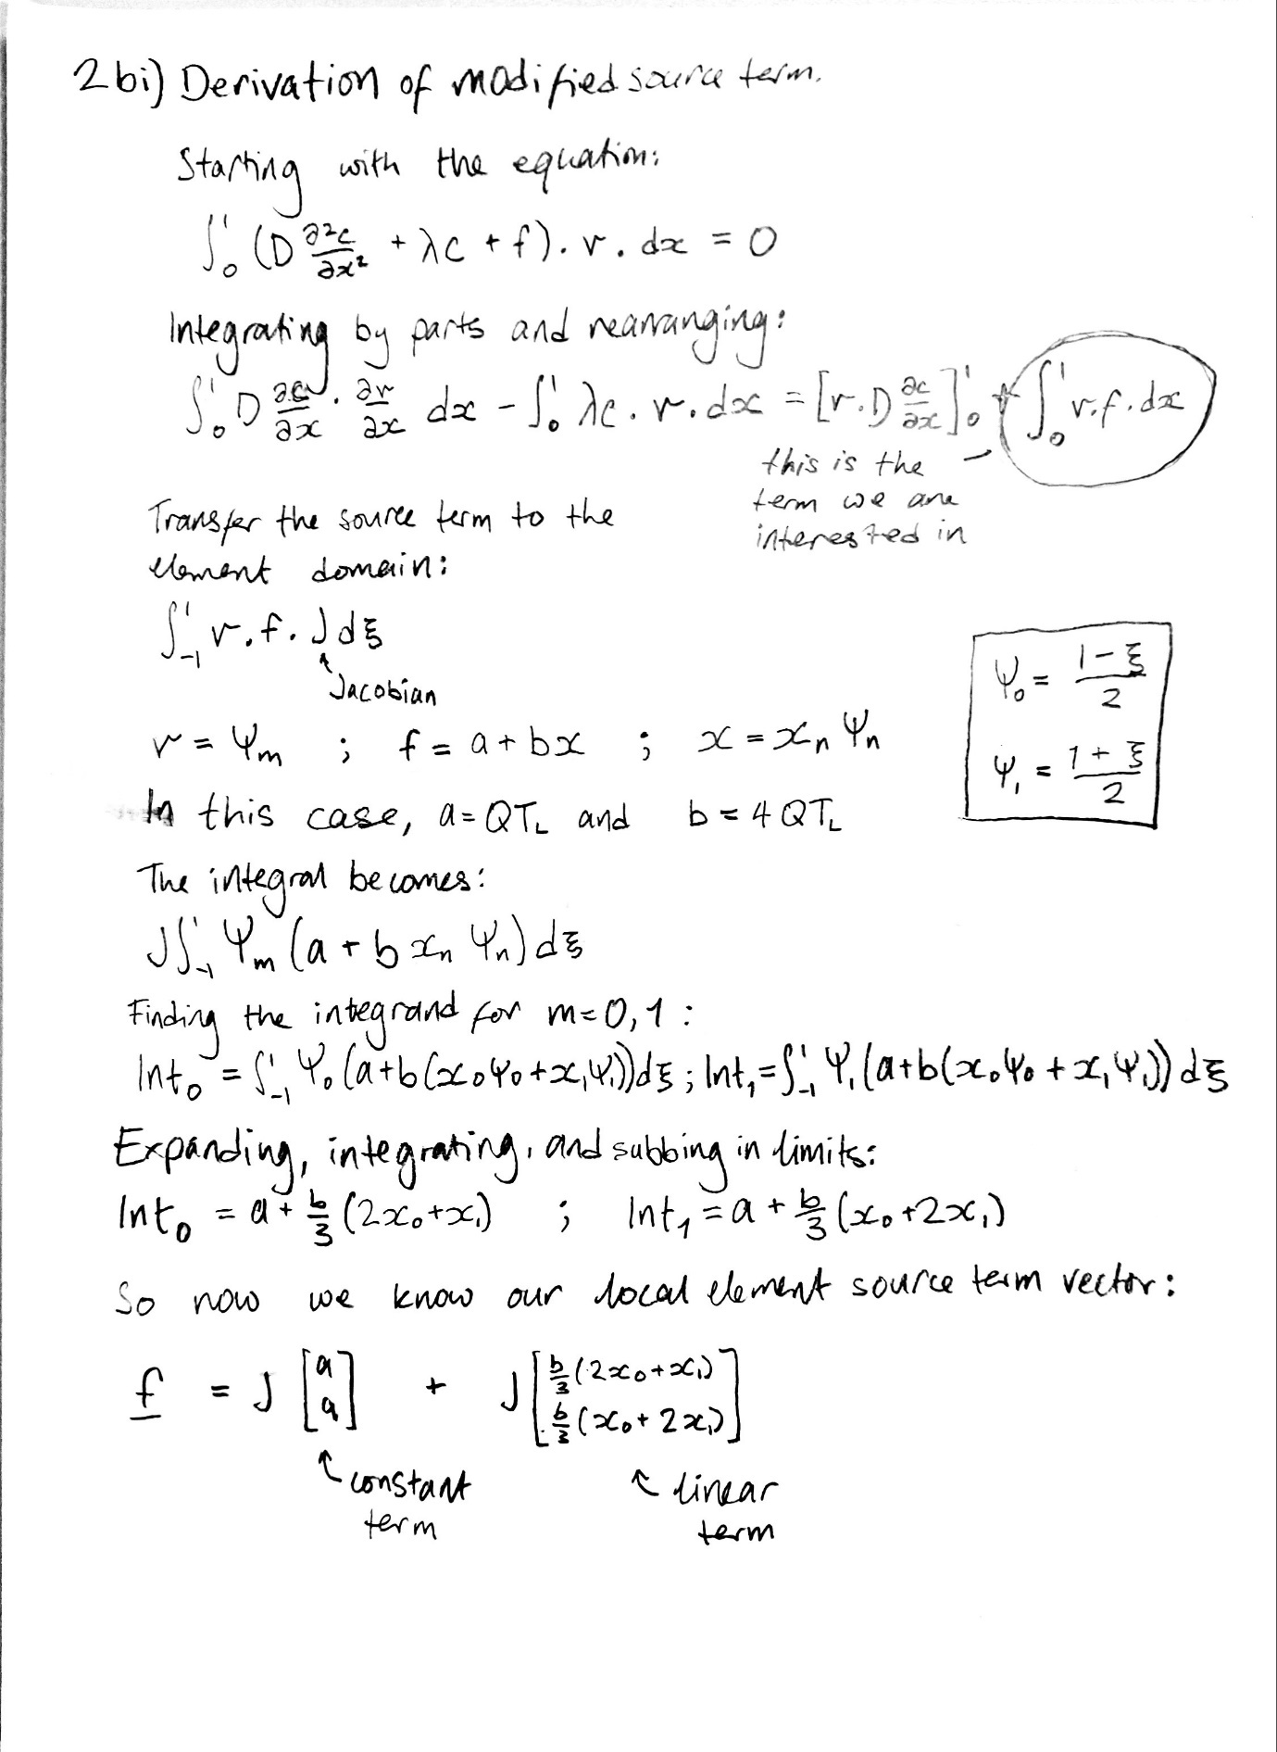

Figure 12: Derivation of modified source term

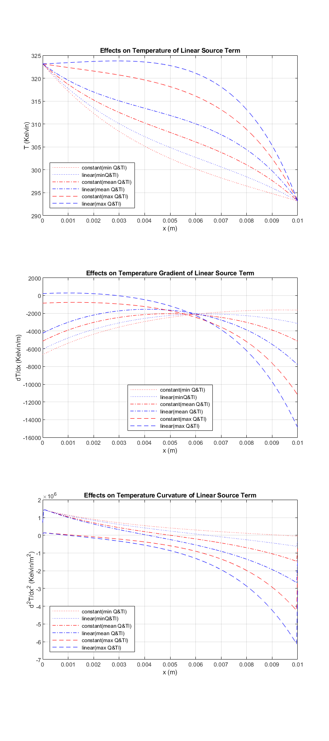

Figure 13: Effects on Temperature, Temperature Gradient, and Temperature Curvature of using a Linear Source term rather than a Constant Source term

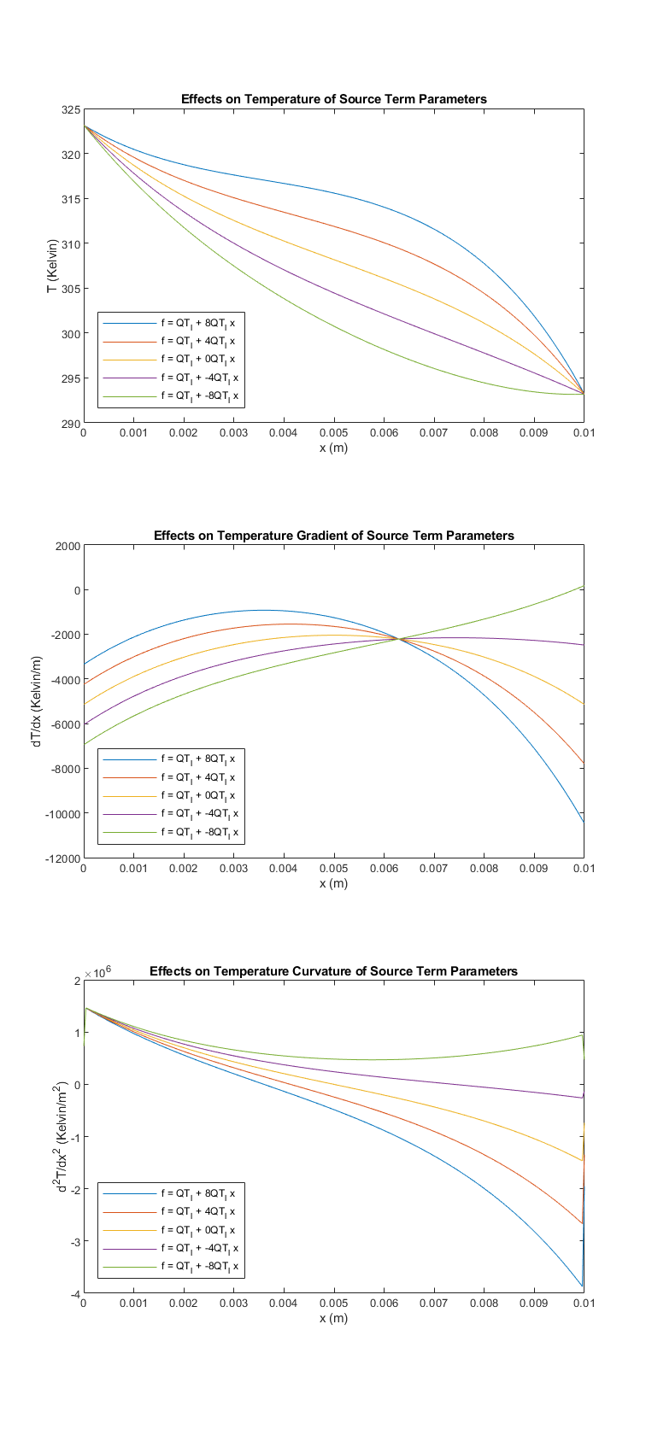

Figure 14: Effects on Temperature, Temperature Gradient, and Temperature Curvature of varying the linear coefficient of the source term

# Appendix: Source Code

## LaplaceElemMatrix function

function L = LaplaceElemMatrix(D,eN,mesh)

% function to calculate local element matrix for diffusion term

x = mesh.elem(eN).x;

J = mesh.elem(eN).J;

dXiX = 2/(x(2)-x(1));

dPhiXi = [-1/2 1/2];

if isnumeric(D)

L = zeros(2,2);

else

L = sym(zeros(2,2)); % allows for symbolic D if desired

end

for n = 1:2

for m = 1:2

L(n,m) = 2*D* dPhiXi(n)*dXiX * dPhiXi(m)*dXiX * J;

end

end

end

## ReactionElemMatrix function

function R = ReactionElemMatrix(lambda,eN,mesh)

% function to calculate local element matrix for diffusion term

J = mesh.elem(eN).J;

Int = [2/3 1/3; 1/3 2/3];

R = J * lambda * Int;

end

## ReactionUnitTest script

%% Test 1: test symmetry of the matrix

% Test that this matrix is symmetric

tol = 1e-14;

lambda = 2; % reaction coefficient

eID=1; % element ID

msh = OneDimLinearMeshGen(0,1,10);

elemat = ReactionElemMatrix(lambda,eID,msh);

assert(abs(elemat(1,2) - elemat(2,1)) <= tol)

%% Test 2: test 2 different elements of the same size produce same matrix

% % Test that for two elements of an equispaced mesh, as described in the

% % lectures, the element matrices calculated are the same

tol = 1e-14;

lambda = 5; % reaction coefficient

eID=1; % element ID

msh = OneDimLinearMeshGen(0,1,10);

elemat1 = ReactionElemMatrix(lambda,eID,msh);

eID=2; % element ID

elemat2 = ReactionElemMatrix(lambda,eID,msh);

diff = elemat1 - elemat2;

diffnorm = sum(sum(diff.*diff));

assert(abs(diffnorm) <= tol)

%% Test 3: test that one matrix is evaluted correctly

% % Test that element 1 of the three element mesh problem described in the tutorials

% % the element matrix is evaluated correctly

tol = 1e-14;

lambda = 1; % reaction coefficient

eID=1; % reaction ID

msh = OneDimLinearMeshGen(0,1,3);

elemat1 = ReactionElemMatrix(lambda,eID,msh);

elemat2 = [ 1/9 1/18 ; 1/18 1/9];

diff = elemat1 - elemat2; % calculate the difference between the two matrices

diffnorm = sum(sum(diff.*diff)); % calculates the total squared error between the matrices

assert(abs(diffnorm) <= tol)

## ElemVector function

function f = ElemVector(F,eN,mesh)

% function to calculate local element matrix for diffusion term

x0 = mesh.elem(eN).x(1);

x1 = mesh.elem(eN).x(2);

J = mesh.elem(eN).J;

switch length(F)

case 1

f = [F;F] * J;

case 2

A = [F(1);F(1)] * J;

B = [(2*x0 + x1)*F(2)/3 ; (x0 + 2*x1)*F(2)/3] * J;

f = A + B;

otherwise

error('Invalid source term')

end

end

## FEMsolver function

function [x,c] = FEMsolver(xmin,xmax,Ne,D,lambda,F,BCs)

% FEM solver.

% initialise mesh

mesh = OneDimLinearMeshGen(xmin, xmax, Ne);

% create and initialise global matrix and vector

M = zeros(mesh.ngn, mesh.ngn);

f = zeros(mesh.ngn,1);

%loop over elements

for i = 1:Ne

% calculate local element matrices and add to global matrix

L = LaplaceElemMatrix(D,i,mesh);

R = ReactionElemMatrix(lambda,i,mesh);

M(i:i+1, i:i+1) = M(i:i+1, i:i+1) + L - R;

% calculate local element vectors and add to global vector

f(i:i+1) = f(i:i+1) + ElemVector(F,i,mesh);

end

% apply boundary conditions

% first, neumann

if ~isnan(BCs(3)) % at xmin

f(1) = f(1) - BCs(3);

end

if ~isnan(BCs(4)) % at xmax

f(mesh.ngn) = f(mesh.ngn) + BCs(4);

end

% then, dirichlet

if ~isnan(BCs(1)) % at xmin

M(1,:) = 0;

M(1,1) = 1;

f(1) = BCs(1);

end

if ~isnan(BCs(2)) % at xmax

M(mesh.ngn,:) = 0;

M(mesh.ngn,mesh.ngn) = 1;

f(mesh.ngn) = BCs(2);

end

% solve the final matrix system

c = M \ f;

x = mesh.nvec';

% plot the solution vector

end

## analytical_tests script

%% Analytical Test 1ci: Laplace's Equation with two Dirichlet BCs

xmin = 0;

xmax = 1;

Ne = 4;

D = 1;

lambda = 0;

F = 0;

BCs = [2 0 NaN NaN]; % dirichlet boundary conditions

[x,c] = FEMsolver(xmin,xmax,Ne,D,lambda,F,BCs);

xA = x; cA = 2*(1-x);

plot(x,c,'x-',xA,cA,'--');

title("Laplace's Equation with Two Dirichlet Boundary Conditions");

xlabel('x'); ylabel('c');

legend('numerical','analytical');

grid on

% save as png

saveas(gcf, 'Test1ci.png')

pause(0.1)

%% Analytical Test 1cii: Laplace's Equation with Dirichlet and Neumann Bxmin = 0;

BCs = [NaN 0 2 NaN]; % one dirichlet and one neumann boundary condition

[x,c] = FEMsolver(xmin,xmax,Ne,D,lambda,F,BCs);

plot(x,c,'x-');

title("Laplace's Equation with Dirichlet and Neumann Boundary Conditions");

xlabel('x'); ylabel('c');

grid on

% save as png

saveas(gcf, 'Test1cii.png')

pause(0.1)

%% Analytical Test 1ciii: Diffusion-Reaction Equation

Ne = [2 3 4 5 50]; % different numbers of elements to test effect of mesh density

lambda = -9; % reaction coefficient

BCs = [0 1 NaN NaN]; % dirichlet boundary conditions

% plot analytical solution

xA = 0:0.01:1;

cA = (exp(3) / (exp(6)-1)) * (exp(3*xA) - exp(-3*xA));

plot(xA,cA,'k','Linewidth',1);

grid on

ylim([0 1])

hold on

labels{1} = 'analytical';

for i = 1:length(Ne) % plot numerical solution with different mesh resolutions

[x,c] = FEMsolver(xmin,xmax,Ne(i),D,lambda,F,BCs);

plot(x,c,'--');

labels{i+1} = num2str(Ne(i), '%d elements');

end

legend(labels,'Location','northwest')

title("Diffusion-Reaction Equation with Different Mesh Resolutions");

xlabel('x'); ylabel('c');

% save as png

saveas(gcf, 'Test1ciii.png')

pause(0.1)

close

clearvars

## ThermophoresisCaseStudy script

% This script was written to model and simulate the behaviour of a

% thermophoresis system.

%% defining parameters

xmin = 0;

xmax = 0.01;

Ne = 500;

Tout = 323.15;

Tin = 293.15;

BCs = [Tout Tin NaN NaN];

k = 1.01e-5;

Q = 0.5:0.25:1.5;

Tl = 294.15:7:322.15;

%% modelling effects of varying flow rate Q

cQ = zeros(Ne+1,length(Q),3);

for i = 1:length(Q)

% min Tl

F = Q(i)*min(Tl);

[x, cQ(:,i,1)] = FEMsolver(xmin,xmax,Ne,k,-Q(i),F,BCs);

% mean Tl

F = Q(i)*mean(Tl);

[~, cQ(:,i,2)] = FEMsolver(xmin,xmax,Ne,k,-Q(i),F,BCs);

% max Tl

F = Q(i)*max(Tl);

[~, cQ(:,i,3)] = FEMsolver(xmin,xmax,Ne,k,-Q(i),F,BCs);

end

% cQ(:,(length(Q)+1)/2,:) = [];

%% modelling effects of varying liquid temp Tl

cTl = zeros(Ne+1,length(Tl),3);

for i = 1:length(Tl)

% min Q

F = Tl(i)*min(Q);

[~, cTl(:,i,1)] = FEMsolver(xmin,xmax,Ne,k,-min(Q),F,BCs);

% mean Q

F = Tl(i)*mean(Q);

[~, cTl(:,i,2)] = FEMsolver(xmin,xmax,Ne,k,-mean(Q),F,BCs);

% max Q

F = Tl(i)*max(Q);

[~, cTl(:,i,3)] = FEMsolver(xmin,xmax,Ne,k,-max(Q),F,BCs);

end

%% comparing linear or constant source term

cS = zeros(Ne+1,2);

a = 1; b = 4;

% min Q, Tl

F = [a*min(Q)*min(Tl) b*min(Q)*min(Tl)];

[~, cS(:,1,1)] = FEMsolver(xmin,xmax,Ne,k,-min(Q),F(1),BCs); % constant

[~, cS(:,2,1)] = FEMsolver(xmin,xmax,Ne,k,-min(Q),F,BCs); %linear

% mean Q,Tl

F = [a*mean(Q)*mean(Tl) b*mean(Q)*mean(Tl)];

[~, cS(:,1,2)] = FEMsolver(xmin,xmax,Ne,k,-mean(Q),F(1),BCs);

[~, cS(:,2,2)] = FEMsolver(xmin,xmax,Ne,k,-mean(Q),F,BCs);

% max Q, Tl

F = [a*max(Q)*max(Tl) b*max(Q)*max(Tl)];

[~, cS(:,1,3)] = FEMsolver(xmin,xmax,Ne,k,-max(Q),F(1),BCs);

[~, cS(:,2,3)] = FEMsolver(xmin,xmax,Ne,k,-max(Q),F,BCs);

%% varying source term parameters (with mean Q and Tl)

a = 1; b = [8 4 0 -4 -8];

cSp = zeros(Ne+1,length(b));

for i = 1:length(b)

F = [a*mean(Q)*mean(Tl) b(i)*mean(Q)*mean(Tl)];

[~, cSp(:,i)] = FEMsolver(xmin,xmax,Ne,k,-mean(Q),F,BCs);

end

% to do: -generate labels -calculate grad and curv -plot trio and save

%% generate labels for legends

% varying Q

Qlabels = string([]);

for i = 1:length(Q)

Qlabels(i) = strcat("Q = ", num2str(Q(i)));

end

% varying Tl

Tlabels = string([]);

for i = 1:length(Tl)

Tlabels(i) = strcat("Tl = ", num2str(Tl(i)));

end

% varying source term

Slabels = {'constant(min Q&Tl)', 'linear(minQ&Tl)',...

'constant(mean Q&Tl)','linear(mean Q&Tl)',...

'constant(max Q&Tl)', 'linear(max Q&Tl)'};

% varying source term parameters

Splabels = {};

for i = 1:length(b)

Splabels{i} = num2str(b(i),'f = QT_l + %dQT_l x');

end

%% plot results

% varying Q

figure('units','normalized','outerposition',[0 0 1 1]) % maximise figure

subplot(2,3,1); % min Tl

plot(x,cQ(:,:,1));

grid on

title('Effects on Temperature of Varying Q (min Tl)')

xlabel('x (m)'); ylabel('T (Kelvin)');

legend(Qlabels)

subplot(2,3,2); %mean Tl

plot(x,cQ(:,:,2));

grid on

title('Effects on Temperature of Varying Q (mean Tl)')

xlabel('x (m)'); ylabel('T (Kelvin)');

legend(Qlabels)

subplot(2,3,3); % max Tl

plot(x,cQ(:,:,3));

grid on

title('Effects on Temperature of Varying Q (max Tl)')

xlabel('x (m)'); ylabel('T (Kelvin)');

legend(Qlabels)

% varying Tl

subplot(2,3,4); % min Q

plot(x,cTl(:,:,1));

grid on

title('Effects on Temperature of Varying Tl (min Q)')

xlabel('x (m)'); ylabel('T (Kelvin)');

legend(Tlabels)

subplot(2,3,5); % mean Q

plot(x,cTl(:,:,2));

grid on

title('Effects on Temperature of Varying Tl (mean Q)')

xlabel('x (m)'); ylabel('T (Kelvin)');

legend(Tlabels)

subplot(2,3,6); % max Q

plot(x,cTl(:,:,3));

grid on

title('Effects on Temperature of Varying Tl (max Q)')

xlabel('x (m)'); ylabel('T (Kelvin)');

legend(Tlabels)

% save as png

saveas(gcf,'parameter_space_temp.png')

pause(0.1); close

% varying source term

figure('units','normalized','outerposition',[0.25 0.25 0.5 0.5]) % resize figure

subplot(1,1,1);

plot(x,cS(:,1,1),'r:',x,cS(:,2,1),'b:');

hold on

grid on

plot(x,cS(:,1,2),'r-.',x,cS(:,2,2),'b-.');

plot(x,cS(:,1,3),'r--',x,cS(:,2,3),'b--');

title('Effects on Temperature of Linear Source Term')

xlabel('x (m)'); ylabel('T (Kelvin)');

legend(Slabels, 'Location','southwest')

% save as png

saveas(gcf,'source_term_temp.png')

pause(0.1); close

%% finding gradients

h = x(2)-x(1);

% varying Q

cQgrad = zeros(Ne+1,length(Q) ,3);

cQgrad2 = zeros(Ne+1,length(Q) ,3);

for i = 1:length(Q)

for j = 1:3

cQgrad(:,i,j) = gradient(cQ(:,i,j),h);

cQgrad2(:,i,j) = gradient(cQgrad(:,i,j),h);

end

end

% varying Tl

cTlgrad = zeros(Ne+1,length(Tl),3);

cTlgrad2 = zeros(Ne+1,length(Tl),3);

for i = 1:length(Tl)

for j = 1:3

cTlgrad(:,i,j) = gradient(cTl(:,i,j),h);

cTlgrad2(:,i,j) = gradient(cTlgrad(:,i,j),h);

end

end

% varying source term

cSgrad = zeros(Ne+1,2,size(cS,3));

cSgrad2 = zeros(Ne+1,2,size(cS,3));

for i = 1:2

for j = 1:size(cS,3)

cSgrad(:,i,j) = gradient(cS(:,i,j),h);

cSgrad2(:,i,j) = gradient(cSgrad(:,i,j),h);

end

end

% varying source term parameters

cSpgrad = zeros(Ne+1,length(b));

cSpgrad2 = zeros(Ne+1,length(b));

for i = 1:length(b)

cSpgrad(:,i) = gradient(cSp(:,i),h);

cSpgrad2(:,i) = gradient(cSpgrad(:,i),h);

end

%% plot gradients

% varying Q

figure('units','normalized','outerposition',[0 0 1 1]) % maximise figure

subplot(2,3,1); % min

plot(x,cQgrad(:,:,1));

grid on

title('Effects on Temperature Gradient of Varying Q (min Tl)')

xlabel('x (m)'); ylabel('dT/dx (Kelvin/m)');

legend(Qlabels,'Location','south')

subplot(2,3,2); %mean

plot(x,cQgrad(:,:,2));

grid on

title('Effects on Temperature Gradient of Varying Q (mean Tl)')

xlabel('x (m)'); ylabel('dT/dx (Kelvin/m)');

legend(Qlabels,'Location','south')

subplot(2,3,3); % max

plot(x,cQgrad(:,:,3));

grid on

title('Effects on Temperature Gradient of Varying Q (max Tl)')

xlabel('x (m)'); ylabel('dT/dx (Kelvin/m)');

legend(Qlabels,'Location','south')

% varying Tl

subplot(2,3,4); % min

plot(x,cTlgrad(:,:,1));

grid on

title('Effects on Temperature Gradient of Varying Tl (min Q)')

xlabel('x (m)'); ylabel('dT/dx (Kelvin/m)');

legend(Tlabels,'Location','south')

subplot(2,3,5);

plot(x,cTlgrad(:,:,2));

grid on

title('Effects on Temperature Gradient of Varying Tl (mean Q)')

xlabel('x (m)'); ylabel('dT/dx (Kelvin/m)');

legend(Tlabels,'Location','south')

subplot(2,3,6);

plot(x,cTlgrad(:,:,3));

grid on

title('Effects on Temperature Gradient of Varying Tl (max Q)')

xlabel('x (m)'); ylabel('dT/dx (Kelvin/m)');

legend(Tlabels,'Location','south')

% save as png

saveas(gcf, 'parameter_space_grad.png')

pause(0.1); close

% varying source term

figure('units','normalized','outerposition',[0.25 0.25 0.5 0.5]) % resize figure

subplot(1,1,1);

plot(x,cSgrad(:,1,1),'r:',x,cSgrad(:,2,1),'b:');

hold on

grid on

plot(x,cSgrad(:,1,2),'r-.',x,cSgrad(:,2,2),'b-.');

plot(x,cSgrad(:,1,3),'r--',x,cSgrad(:,2,3),'b--');

title('Effects on Temperature Gradient of Linear Source Term')

xlabel('x (m)'); ylabel('dT/dx (Kelvin/m)');

legend(Slabels,'Location','south')

% save as png

saveas(gcf, 'source_term_grad.png')

pause(0.1); close

%% plot curvatures

% varying Q

figure('units','normalized','outerposition',[0 0 1 1]) % maximise figure

subplot(2,3,1); % min

plot(x,cQgrad2(:,:,1));

grid on

title('Effects on Temperature Curvature of Varying Q (min Tl)')

xlabel('x (m)'); ylabel('d^2T/dx^2 (Kelvin/m^2)');

legend(Qlabels)

subplot(2,3,2); %mean

plot(x,cQgrad2(:,:,2));

grid on

title('Effects on Temperature Curvature of Varying Q (mean Tl)')

xlabel('x (m)'); ylabel('d^2T/dx^2 (Kelvin/m^2)');

legend(Qlabels)

subplot(2,3,3); % max

plot(x,cQgrad2(:,:,3));

grid on

title('Effects on Temperature Curvature of Varying Q (max Tl)')

xlabel('x (m)'); ylabel('d^2T/dx^2 (Kelvin/m^2)');

legend(Qlabels)

% varying Tl

subplot(2,3,4); % min

plot(x,cTlgrad2(:,:,1));

grid on

title('Effects on Temperature Curvature of Varying Tl (min Q)')

xlabel('x (m)'); ylabel('d^2T/dx^2 (Kelvin/m^2)');

legend(Tlabels)

subplot(2,3,5);

plot(x,cTlgrad2(:,:,2));

grid on

title('Effects on Temperature Curvature of Varying Tl (mean Q)')

xlabel('x (m)'); ylabel('d^2T/dx^2 (Kelvin/m^2)');

legend(Tlabels)

subplot(2,3,6);

plot(x,cTlgrad2(:,:,3));

grid on

title('Effects on Temperature Curvature of Varying Tl (max Q)')

xlabel('x (m)'); ylabel('d^2T/dx^2 (Kelvin/m^2)');

legend(Tlabels)

% save as png

saveas(gcf, 'parameter_space_curv.png')

pause(0.1); close

% varying source term

figure('units','normalized','outerposition',[0.25 0.25 0.5 0.5]) % resize figure

subplot(1,1,1);

plot(x,cSgrad2(:,1,1),'r:',x,cSgrad2(:,2,1),'b:');

hold on

grid on

plot(x,cSgrad2(:,1,2),'r-.',x,cSgrad2(:,2,2),'b-.');

plot(x,cSgrad2(:,1,3),'r--',x,cSgrad2(:,2,3),'b--');

title('Effects on Temperature Curvature of Linear Source Term')

xlabel('x (m)'); ylabel('d^2T/dx^2 (Kelvin/m^2)');

legend(Slabels, 'Location','southwest')

% save as png

saveas(gcf, 'source_term_curv.png')

pause(0.1); close

%% plotting tiled source term figures - constant/linear

% constant/linear temp

figure('units','normalized','outerposition',[0.33 0 0.33 1]) % resize figure

subplot(3,1,1);

plot(x,cS(:,1,1),'r:',x,cS(:,2,1),'b:');

hold on

grid on

plot(x,cS(:,1,2),'r-.',x,cS(:,2,2),'b-.');

plot(x,cS(:,1,3),'r--',x,cS(:,2,3),'b--');

title('Effects on Temperature of Linear Source Term')

xlabel('x (m)'); ylabel('T (Kelvin)');

legend(Slabels, 'Location','southwest')

% constant/linear gradient

subplot(3,1,2);

plot(x,cSgrad(:,1,1),'r:',x,cSgrad(:,2,1),'b:');

hold on

grid on

plot(x,cSgrad(:,1,2),'r-.',x,cSgrad(:,2,2),'b-.');

plot(x,cSgrad(:,1,3),'r--',x,cSgrad(:,2,3),'b--');

title('Effects on Temperature Gradient of Linear Source Term')

xlabel('x (m)'); ylabel('dT/dx (Kelvin/m)');

legend(Slabels,'Location','south')

% constant/linear curvature

subplot(3,1,3);

plot(x,cSgrad2(:,1,1),'r:',x,cSgrad2(:,2,1),'b:');

hold on

grid on

plot(x,cSgrad2(:,1,2),'r-.',x,cSgrad2(:,2,2),'b-.');

plot(x,cSgrad2(:,1,3),'r--',x,cSgrad2(:,2,3),'b--');

title('Effects on Temperature Curvature of Linear Source Term')

xlabel('x (m)'); ylabel('d^2T/dx^2 (Kelvin/m^2)');

legend(Slabels, 'Location','southwest')

% print A4 size png

fig = gcf;

fig.PaperUnits = 'centimeters';

fig.PaperPosition = [0 0 20 45];

print('source_term_trio.png','-dpng','-r0')

pause(0.1); close

%% plotting tiled source term figures - parameters

% parameter temp

figure('units','normalized','outerposition',[0.33 0 0.33 1]) % resize figure

subplot(3,1,1);

plot(x,cSp);

title('Effects on Temperature of Source Term Parameters')

xlabel('x (m)'); ylabel('T (Kelvin)');

legend(Splabels, 'Location','southwest')

% parameter gradient

subplot(3,1,2);

plot(x,cSpgrad);

title('Effects on Temperature Gradient of Source Term Parameters')

xlabel('x (m)'); ylabel('dT/dx (Kelvin/m)');

legend(Splabels, 'Location','southwest')

% parameter curvature

subplot(3,1,3);

plot(x,cSpgrad2);

title('Effects on Temperature Curvature of Source Term Parameters')

xlabel('x (m)'); ylabel('d^2T/dx^2 (Kelvin/m^2)');

legend(Splabels, 'Location','southwest')

% print A4 size png

fig = gcf;

fig.PaperUnits = 'centimeters';

fig.PaperPosition = [0 0 20 45];

print('source_term__para_trio.png','-dpng','-r0')

pause; close

%% looking at mesh resolution

Ne = [2 3 4 5 10 20];

figure('units','normalized','outerposition',[0.25 0.25 0.5 0.5]) % resize figure

subplot(1,1,1)

for i = 1:length(Ne)

[x,c] = FEMsolver(xmin,xmax,Ne(i),k,-max(Q),max(Q)*mean(Tl),BCs);

plot(x,c);

hold on

grid on

Mlabels{i} = num2str(Ne(i),'%d elements');

end

% plot high res for comparison

Ne = 100;

[x,c] = FEMsolver(xmin,xmax,Ne,k,-max(Q),max(Q)*mean(Tl),BCs);

plot(x,c,'k--','Linewidth',1);

labels{i+1} = num2str(Ne,'%d elements');

legend(Mlabels);

title('Investigating Effects of Mesh Density for mean Tl and max Q')

xlabel('x(m)'); ylabel('T(Kelvin)');

% save as png

saveas(gcf, 'convergence.png')

pause(0.1); close; clearvars